Press Release

Service 4.0 in Turbulent Times

Direct VIEW S from Höfelmeyer provides comprehensive instant solutions across distances

During this time, it’s not just private individuals who are trying to avoid making social contacts. It’s also important for companies to protect their employees. Technology that works perfectly is essential in order not to put an additional strain on production in this exceptional situation. A fast, expert and as cost-efficient as possible fault and procedure service is thus becoming increasingly important. This is where digitalisation and especially Service 4.0 provide powerful advantages – not just in times of ‘social distancing’.

Höfelmeyer Waagen’s ‘Direct VIEW S’ remote service represents a reliable and secure solution for viewing and analysing all measurement and inspection components on the basis of augmented reality (AR), and for rectifying malfunctions. In this way, many questions in connection with an optimal alignment of systems and processes can also be answered easily and effectively.

If necessary, the customer’s employee initiates remote access from their smartphone, tablet or data glasses. In this way, the Höfelmeyer service technician can use the camera to obtain a first-hand picture of the situation on site – in real time. System problems and downtimes are thus recorded more quickly, easily and more completely than via telephone, and errors diagnosed. When rectifying the fault, the Höfelmeyer expert guides the employee step by step. Via voice and virtual tools such as hand overlays, pointers, integrated documents, graphics etc., any instruction, no matter how complex, can be carried out. This procedure often prevents an on-site service call involving long travel times and high travel costs. Production downtimes can sometimes be avoided completely or downtimes and costs minimised. However, if a subsequent repair job is necessary – e.g. in the event of a hardware defect – this can be planned and carried out much more efficiently.

In addition, proactive digital status analyses are possible. These allow the hardware and general functionality to be assessed. System availability and performance can be ensured in the long term by addressing changes in operation in terms of noises, temperatures etc. etc. at an early stage.

Networking in production is constantly increasing. Thus, a competent digital service is also extremely useful for the interaction of all measurement and inspection components, regardless of manufacturer. This involves the holistic consideration and fine tuning of hardware, processes and software packages for control and analysis (such as Höfelmeyer IRIS). Höfelmeyer’s experts provide starting points for optimisation with their cross-technology and cross-sector perspective. Speed of response and efficiency of support is also increased.

Direct VIEW S can also provide important assistance at any time in the event of operating errors/uncertainties or general technical questions. Digital instructions competently train employees in handling the systems. This is where the possibility of video recording provides additional added value.

Direct VIEW S is an intuitively operated service tool. It can be used via app on existing mobile devices across platforms. Special Smart Glasses offer the additional advantage that both hands are free to solve problems. The highest security standards are implemented for data transmission. The digital service also applies to third-party products.

www.hoefelmeyer.de
Characters: 3,679

About Höfelmeyer:

Höfelmeyer Waagen GmbH is an innovative scale manufacturer, processor, and service partner. From compact scales through modular weighing systems to custom-made special applications, the family-owned company has been providing solutions of the highest technical standard for optimal integration into customer processes for over 30 years. The company also offers flexible, expert repair and maintenance services.

Further information via:

Anne-Katrin Schütte
Qualified Marketing and Communications Specialist
Team Leader, Communications & Marketing

Tel. +49 5401 4977 -43 | Fax: +49 5401 4977-90 | A.Schuette@hoefelmeyer.de | www.hoefelmeyer.de

Höfelmeyer Waagen GmbH | Georgsmarienhütte | Hüfingen | Neuss | Hamburg | Leipzig
Tel. +49 5401 4977-0 | Fax +49 5401 4977-90 | waagen@hoefelmeyer.de | www.hoefelmeyer.de

Illustrations:

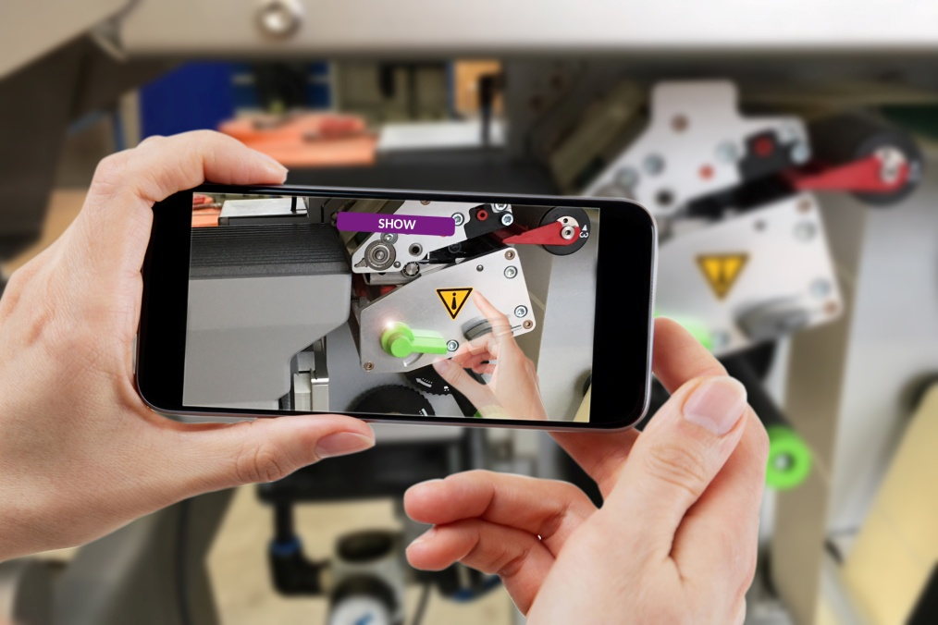

Fig. 1 Höfelmeyer Direct VIEW S - A digital service for safeguarding production

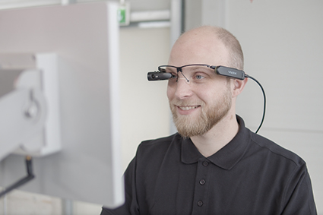

Fig. 2 Problem solution via Smart Glasses

Fig. 3: Höfelmeyer logo

