Press Release

Höfelmeyer Catchweigher
Compact and a secure investment

The constantly increasing pressure on prices in the value chain necessitates both productivity-increasing and cost-cutting measures in all processes. This is where Höfelmeyer’s dynamic catchweighers make an important contribution. Thanks to their modular design, they can be used flexibly – in logistics (CEP, distribution centres), but also as part of processing, manufacturing and intralogistics in the food, chemical, plastic, metal, waste and recycling sectors. With their precise results, these fully automatic weighing systems enable the reliable management and monitoring of goods flows with complete transparency. Not only do they allow for the most accurate accounting, but they also minimise time and effort required as well as error rates.

The main areas of application of Höfelmeyer catchweighers are in the determination of individual weights, unit counting, quality control (completeness) and in the fully automatic process control for piece goods. What is more, they can be expanded into complex stations with modules for volume measurement, identification solutions, labellers etc. An example of this are DWS systems (dimensioning, weighing, scanning). In this way, all relevant data can be completely recorded, processed and made available to higher-level systems in real time. From a single source.

The customisation options for the compact catchweighers include, for example, various weighing ranges, belt widths and lengths, throughput rates, display units, protection classes and interfaces. Cover hoods, remote control cabinets or operating terminals, a reversing mode and use in legal metrology are also possible.

The weighing systems are thus individually customised for the locations and requirements. As part of process integration, they are synchronised with upstream and downstream equipment (feeding, sorting, distribution, shipping, etc.). In addition, the catchweighers are characterised by a low-wear design and user-friendly, intuitive controls.

www.hoefelmeyer.de
Characters: 1,915
About Höfelmeyer:

Höfelmeyer Waagen GmbH is an innovative scale manufacturer, processor, and service partner. From compact scales through modular weighing systems to custom-made special applications, the family-owned company has been providing solutions of the highest technical standard for optimal integration into customer processes for over 30 years. The company also offers flexible, expert repair and maintenance services.

Further information via:

Anne-Katrin Schütte
Team Leader, Communications & Marketing

Tel. +49 5401 4977 -43 | A.Schuette@hoefelmeyer.de | www.hoefelmeyer.de

Höfelmeyer Waagen GmbH
Tel. +49 5401 4977-0 | waagen@hoefelmeyer.de | www.hoefelmeyer.de

Figures:
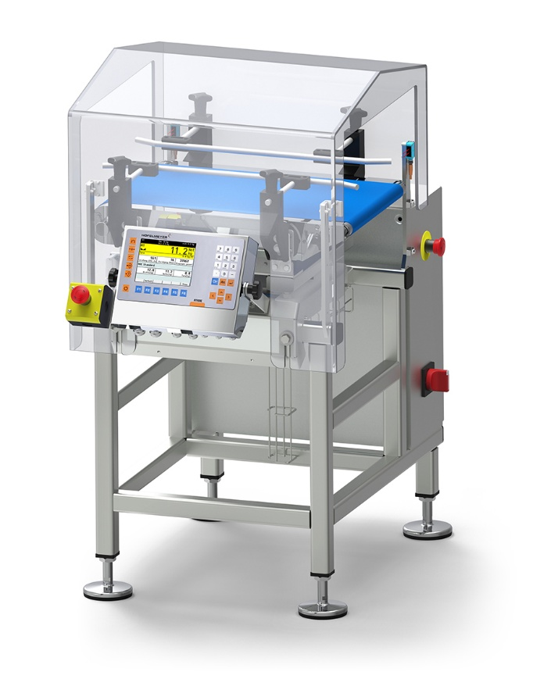

Fig. 1: Dynamic continuous scale from Höfelmeyer with a modular design and unique service package



Fig. 2: Höfelmeyer logo

