Press Release

Product innovation: IBC weighing station with tilting function

Höfelmeyer IBC stations support ergonomic and effective emptying of residues

Intermediate Bulk Containers (IBC) are used in a variety of industries. However, no matter whether it is for emulsions, juices, oils, flavours, additives, paints, colours, etc., the industry recognises again and again the need for improvement initiatives for the handling and emptying of the IBC. Höfelmeyer Waagen has developed a new type of IBC weighing station based on these market requirements, which has since proved itself many times in practice.

The weighing systems are used in interim storage, handling and dosing of liquid substances in industries such as food, chemicals, pharmaceuticals, cosmetics etc. and can be especially adapted to the media and requirements. They consist of a frame made of stainless steel and one or more weighing platforms with tilting devices. The containers are simply and safely positioned on the station by means of a lift truck or forklift (anti-slip protection integrated). With increasing emptying, the containers are tilted by means of gas springs and thereby the emptying of residues is optimised. The tilting position is automatically determined according to the weight, so that production can continue without interruptions.

Depending on the requirements, liquid media are either manually or automatically controlled or dosed. The terminals are installed directly on the frame or alternatively in a control cabinet away from the system. In addition, the IBC station can be completely integrated into existing systems via Ethernet, Profibus or Profinet.

The Höfelmeyer IBC weighing systems are available as 1, 2 and 3 unit stations. A larger number of spaces can be achieved by combining them. Below the frame there are also storage areas for further IBCs. This design allows optimum space utilisation and fast container changes. Production losses are therefore avoided.

The advantages of the weighing systems are also beneficial for viscous products. In addition to the hydrostatic emptying of the containers via the floor outlet, it is also possible to use pumps. In addition, the stations can be combined with mixers and agitators. The systems are rated as protection class IP69K and are designed for 1,000 l IBC. They can also be adapted to containers of other dimensions. Further options are gutters for receiving dripping quantities and explosion-proof versions according to ATEX.

The overall concept is characterised by a design according to Hygienic Design and by simple and safe handling. The stations allow an improved use of resources, increased work ergonomics and safety as well as time savings.

With the IBC weighing stations, Höfelmeyer complements its product portfolio according to its mission of equipping whole factories from incoming goods to outgoing goods with measuring technology.

www.hoefelmeyer.de
Characters: 2,842

About Höfelmeyer:

Höfelmeyer Waagen GmbH is an innovative scale manufacturer, processor, and service partner. From compact scales through modular weighing systems to custom-made special applications, the family-owned company has been providing solutions of the highest technical standard for optimal integration into customer processes for over 30 years. The company also offers flexible, expert repair and maintenance services.

Further information via:

Anne-Katrin Schütte
Qualified Marketing and Communications Specialist
Team Leader, Communications & Marketing

Tel. +49 5401 4977 -43 | A.Schuette@hoefelmeyer.de | www.hoefelmeyer.de

Höfelmeyer Waagen GmbH
Tel. +49 5401 4977-0 | waagen@hoefelmeyer.de | www.hoefelmeyer.de

Figures:

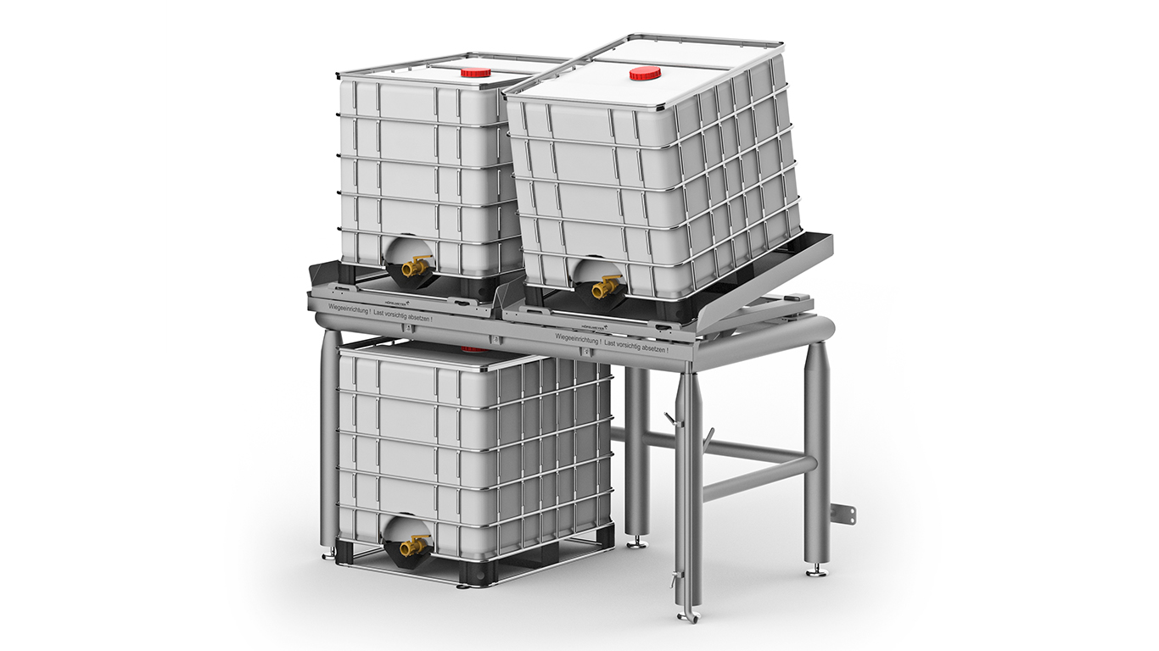

Fig. 1: IBC weighing station from Höfelmeyer



Fig. 3: Höfelmeyer Logo

