Presseinformation

Precise measurements in various locations

Portable scales from Höfelmeyer for a wide range of requirements

Being able to capture on-site weight measurements during ongoing operations offers great potential. The use of portable scales enables processes such as dosing, filling, formulation and counting to be optimally integrated into production processes. This is especially useful in the event of constantly changing locations. In addition to saving time and effort and improving workplace ergonomics, portable hygienic scales can also improve quality and safety standards. Superior hygiene requirements must be taken into account when weighing, however.

Höfelmeyer’s portable hygienic scales represent a technological all-in-one solution that have already proven themselves multiple times in practice. They are suitable for both stationary and dynamic use, and can be optimally integrated into production processes in the pharmaceutical, chemical, plastics and food industries. They also offer advantages in terms of intralogistics. The scales are hugely adaptable thanks to their high calibration potential, powerful battery, and WiFi data transfer function. They are also suitable for use in clean rooms.

In addition to simple weight measurement tasks such as capturing and displaying weight values, the scales can also be used to dose individual components, formulate multi-component items, count items, and pick orders. If required, the scales’ software can be programmed to take customer-specific processes into account during the weighing process. This enables work processes to be designed more effectively, thus simplifying the entire process and reducing sources of error. The scales’ operating sequence can also be expanded to include a calibration function. Optional tilt sensors ensure that the scales are operated within the specified limits, thus consistently delivering reliable, precise measurement results.

The hygienic scales are modularly equipped according to their application. Different platform dimensions, platform heights, weighing ranges, terminals, rollers and peripheral devices can be combined. Hand scanners make it easier to select articles and/or items in an order, or enter batch data. Printers provide log data and labels for the products. Höfelmeyer’s portable scales are also suitable for use in digitised production processes as part of Industry 4.0. The IRIS modular software package offers a powerful range of data management features, and can be used to monitor, control and analyse various weight and measurement components. This means that all data can be recorded, analysed and processed centrally.

The scales are cast in a single piece, and meet the highest quality and hygiene standards. All components are housed in a stainless steel cabinet with an optional flap for printers. There are no open threads, hidden edges, or dead spaces. The scales are also available in an electro-polished version. In addition, the scales' ergonomic design means that the overall concept is characterized not only by optimal cleanability, but also by smooth operation for flexible and fast work processes.

www.hoefelmeyer.de
Characters: 3,024
About Höfelmeyer:

Höfelmeyer Waagen GmbH is an innovative scale manufacturer, processor, and service partner. From compact scales through modular weighing systems to custom-made special applications, the family-owned company has been providing solutions of the highest technical standard for optimal integration into customer processes for over 30 years. The company also offers flexible, expert repair and maintenance services.

Further information via:

Anne-Katrin Schütte
Qualified Marketing and Communications Specialist
Team Leader, Communications & Marketing

Tel. +49 5401 4977 -43 | A.Schuette@hoefelmeyer.de | www.hoefelmeyer.de

Höfelmeyer Waagen GmbH
Tel. +49 5401 4977-0 | waagen@hoefelmeyer.de | www.hoefelmeyer.de

Figures:

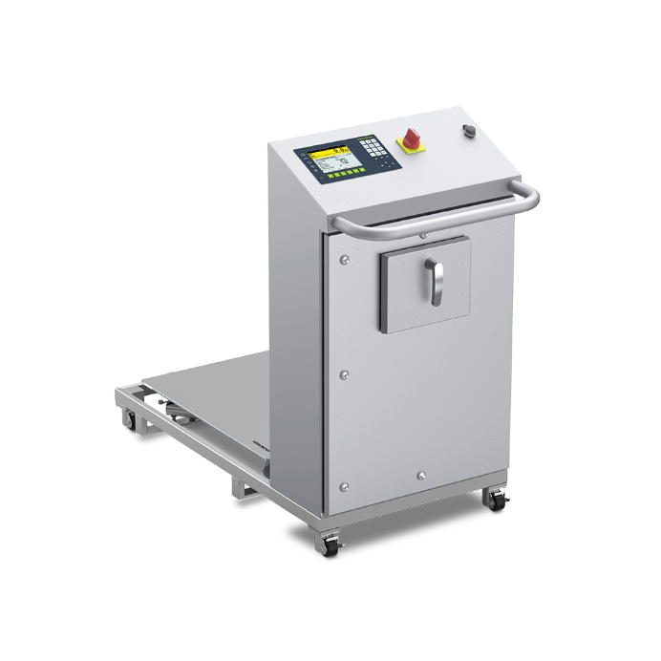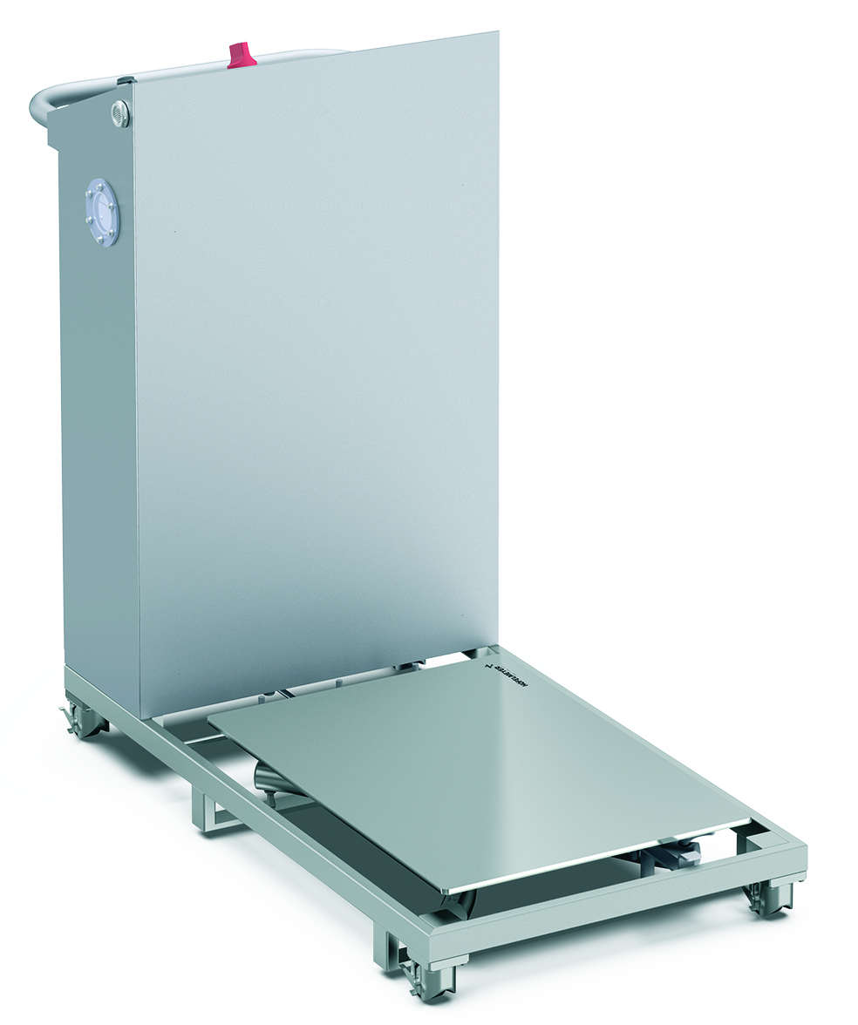

Fig. 1 and 2 Mobile hygienic scale with modular assembly from Höfelmeyer



Fig. 3: Höfelmeyer Logo

