Press Release

Innovation: process station with PC-integrated weighing technology

New generation of Höfelmeyer process stations supports efficient and optimally connected production

Despite increasing automation, the value creation chain in manufacturing companies relies on a wide variety of manual tasks. The trend towards small batch sizes and product individualization further reinforces this. To ensure quality, safety and efficiency, manual work stations too must be seamlessly integrated into the process chain and information systems.

With its process stations, Höfelmeyer Waagen GmbH also supports complex and variable operations in production, packaging, logistics, laboratories and clean rooms, etc. Thanks to their modular structure, the platforms are specially adapted for the manual work to be performed. Furthermore, these can be embedded in the overall chain of operations in terms of processes and information technology, which enables real-time process controls and seamless traceability. Höfelmeyer’s many years of industry experience yield optimally tailored solutions for the food and animal feed, chemical, pharmaceutical, healthcare and logistics industries.

The work stations consist of a solid stand and a powerful, hygienic touch IPC with integrated weighing terminal. The IPC, with all the necessary interfaces, can be integrated into the existing ERP and MES systems. The stations also incorporate additional modules — depending on whether the operation focuses on recipe management, bottling, quality assurance, labeling, laboratory work, etc. Possible options include a wide variety of weighing platforms (hygiene, laboratory, drive-through, floor scales, etc.) printer units, scanners, RFID readers, thermometers, and fat or gas analyzers. Integrated conveyor belts and roller conveyors, enclosures, signaling devices, product containers, packaging material providers, stand rollers, and more enable the tailored adaptation of the system to the requirements of the site involved.

The innovation of the validation-enabled weighing technology lies in the fact that it is directly embedded in the IPC and supports the existing ERP/MES systems. This allows a universal, system-wide operating concept to be realized and enhances clarity, user-friendliness and hygiene.

The modular system from Höfelmeyer offers all the advantages of a specially developed system while being cost-efficient. Whether they are used as standalone products or fully integrated into the system, the process stations feature perfectly coordinated components, an ergonomic concept adapted to the specific workflow, and a slim, robust and hygienic design. They comply with relevant standards, such as IFS, BRC, HACCP, LMIV, FPVO, FDA and GMP, etc. In addition, the customer benefits from comprehensive service from Höfelmeyer in the form of consulting (e.g., weighing and control technology, process design, quality management), and further down the line, from a fast and professional maintenance and repair service.
www.hoefelmeyer.de

January 23, 2017
About Höfelmeyer:

Höfelmeyer Waagen GmbH is an innovative scale manufacturer, processor, and service partner. From compact scales through modular weighing systems to custom-made special applications, the family-owned company has been providing solutions of the highest technical standard for optimal integration into customer processes for over 30 years. The company also offers flexible, expert repair and maintenance services.

Further information via:

Anne-Katrin Schütte
Qualified Marketing and Communications Specialist
Team Leader, Communications & Marketing

Tel. +49 5401 4977 -43 | A.Schuette@hoefelmeyer.de | www.hoefelmeyer.de

Höfelmeyer Waagen GmbH
Tel. +49 5401 4977-0 | waagen@hoefelmeyer.de | www.hoefelmeyer.de

Figures:

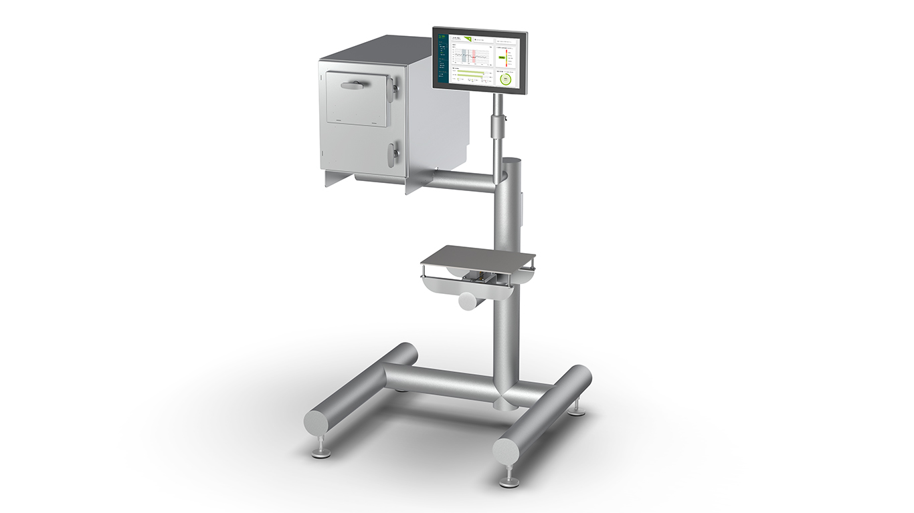

Fig. 1: Process station with weighing platform reduced to a minimum and PC-integrated weighing technology



Fig. 3: Höfelmeyer Logo

